30.56: a)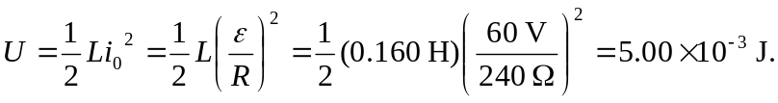
b) 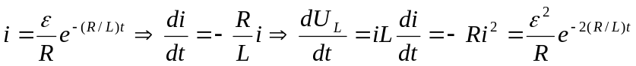
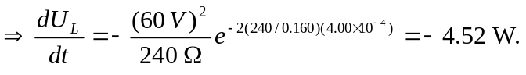
c) In the resistor:
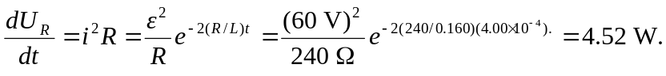
d) 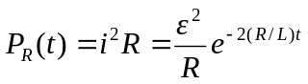
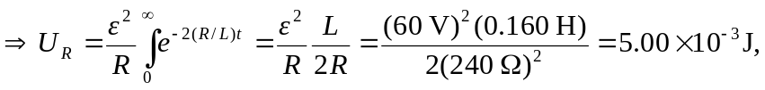
which is the same as part (a).

